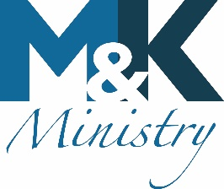
It is the desire of M&K Ministry to minister with the help of the Holy Spirit to find

- Restoration to a right relationship with God
- Recovery from emotional wounds and renewing the mind
- Reconciliation for broken relationships
- Regeneration for broken homes and impact on future generations

Typically, we schedule a two-hour block for each prayer session. You may meet with one, two, or three team members as desired for no extra charge.

The current rate for professional counseling in the Murfreesboro/Nashville area is $120 per 50-minute sessions with one counselor. Because we are an inner-healing prayer ministry, however, and no price can repay our Lord Jesus for the wisdom that He gives, we do not charge for our services.

However, as a faith-based, nonprofit organization, M&K Ministry has on-going expenses, and a minimum donation of $10 to M&K Ministry is appreciated at the time of ministry.

Ways you can give

Online: https://my.simplegive.com/app/giving/mkmi1417171

Text "GIVE" to +16155510895

Download our Mobile App: https://app.ministryone.com/landing/ll4D

Check made out to M&K Ministry and sent to:
M&K Ministry
1784 W Northfield Blvd #149
Murfreesboro TN 37129

Prayer Ministers
Karen Keegan
Minna Kayser
Cheryl Sivacek

